**[Título del documento]**

**[Subtítulo del documento]**

Aaron MR

transporter 4

transporter_C 4

transporter_S 6

Tutorial: 8

Client 8

Server 14

Stack 19

FileSystem 19

Drivers 19

CB_TCP_RTAI 19

Laser_PLS200 19

Other 19

Server_RTAI 19

Robots 19

JKU_maps 19

Robot1 20

R1_2dnav: 20

R1_Odom: 20

R1_launch: 20

R1_teleop_joy: 20

R1_teleop_key: 20

R1_urdf: 20

Scheme for the Power supply. 21

Robot1 23

Robot body: 23

Kinect_sensor 23

Sick Laser PLS200 23

Wheels 2 degree of freedom 23

Final model 24

Install Diamondback in Ubuntu 25

Installation 25

Configure your Ubuntu repositories 25

Setup your sources.list 25

Set up your keys 25

Installation 25

Environment setup 26

Download and compile the stack 27

Install Development Tools 28

Script to install from Code::Blocks from SVN 28

Install Kile from the repositories 28

Setup and Configuration of the Navigation Stack on a Robot 29

Robot Setup 29

ROS 29

Transform Configuration (other transforms) 29

Sensor Information (sensor sources) 29

Odometry Information (odometry source) 29

Base Controller (base controller) 30

Mapping (map_server) 30

Navigation Stack Setup 30

Creating a Package 30

Creating a Robot Configuration Launch File 31

Costmap Configuration (local_costmap) & (global_costmap) 32

Global Configuration (global_costmap) 34

Local Configuration (local_costmap) 34

Full Configuration Options 35

Base Local Planner Configuration 35

Creating a Launch File for the Navigation Stack 35

AMCL Configuration (amcl) 36

Create your own urdf file 37

# transporter

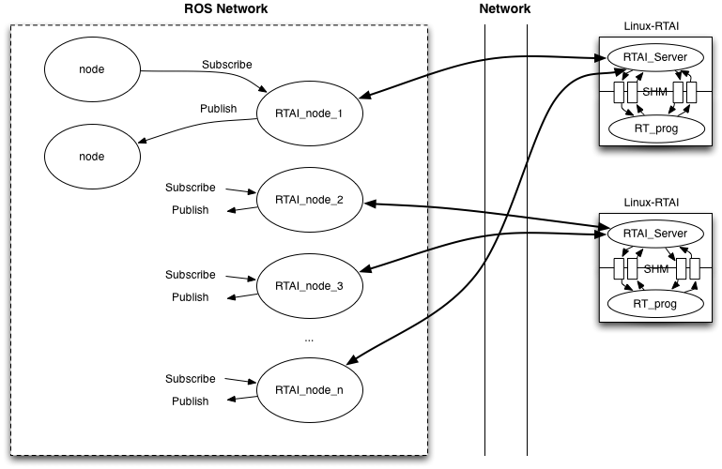

## transporter_C

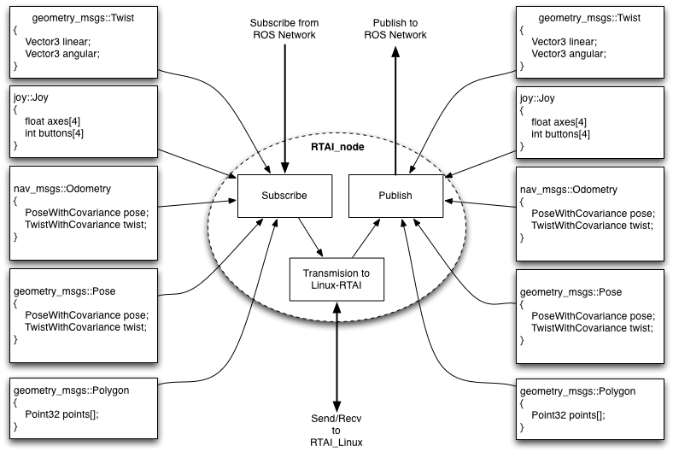

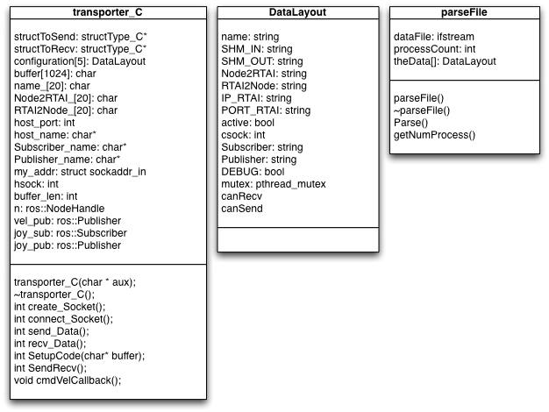

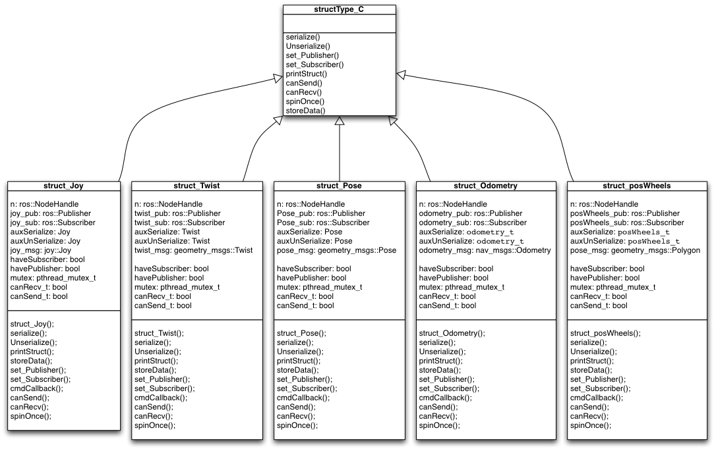

## transporter_S

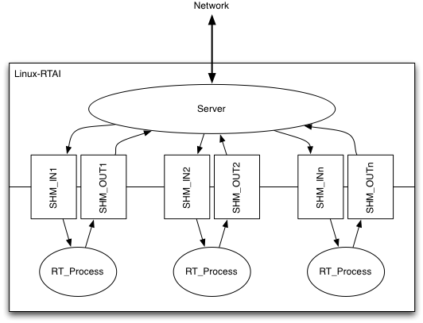

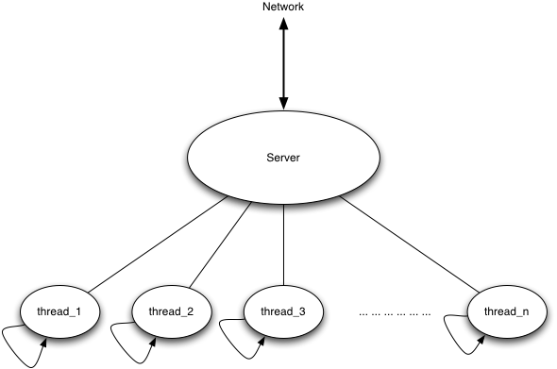

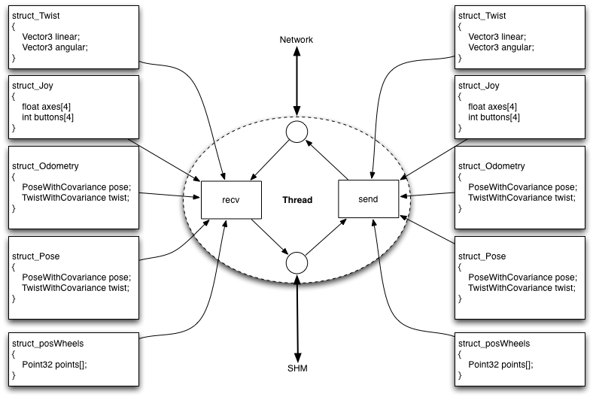

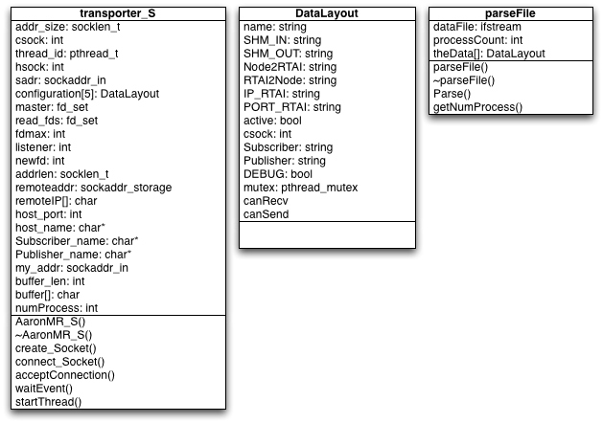

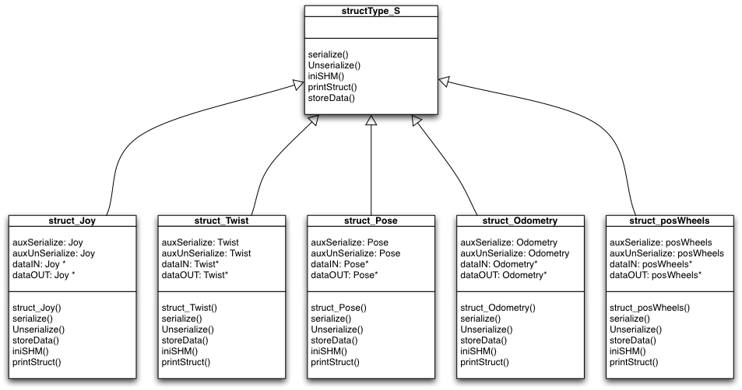

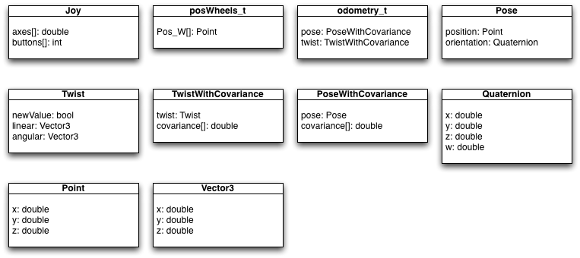

## Tutorial:

Tutorial to create a new struct to send between Client and Server.

This tutorias is for the control of the position of the Wheels of R1 (Mobile platform). The final goal for this struct is to know the position of the wheels to see in rviz with the model in 3d of the platform.

### Client

In the file *JKU_Robotic_Stack / Drivers / CB_TCP_RTAI / include / TCP_RTAI / structType_C.hpp* add the next code:

**class** **struct_posWheels** **:** **public** structType_C {

**public:**

    struct_posWheels();

**int** serialize(**char\*** data2s);

**int** Unserialize(**char\*** data2us);

**int** printStruct(**char\*** data2print);

**void\*** set_Publisher(**char\*** name);

**void\*** set_Subscriber(**char\*** name);

    ros**::**NodeHandle n;

    ros**::**Publisher posWheels_pub;

    ros**::**Subscriber posWheels_sub;

*// struct to send and receive*

    posWheels_t auxSerialize;

    posWheels_t auxUnSerialize;

    geometry_msgs**::**Polygon polygon_msg;

**void** cmdCallback(**const** geometry_msgs**::**Polygon **&**data);

**bool** haveSubscriber;

**bool** havePublisher;

    pthread_mutex_t mutex;

**bool** canRecv_t;

**bool** canSend_t;

**bool** canSend();

**bool** canRecv();

**int** spinOnce();

};

This is a new subclass of the class structType_C. We can see the function and the variables neccesary to send and receive the struct posWheels_t (This class can be seen in the figure where it lists all the structures created)

Now we need create a new file to put the code for the new class. The new file will be in *JKU_Robotic_Stack / Drivers / CB_TCP_RTAI / include / TCP_RTAI / struct_posWheels.cpp* and the code is:

**#include "pack2.hpp"**

**#include "structType_C.hpp"**

struct_posWheels**::**struct_posWheels()

{

    haveSubscriber **=** **false**;

    havePublisher **=** **false**;

    canRecv_t **=** **true**;

    canSend_t **=** **true**;

    mutex **=** PTHREAD_MUTEX_INITIALIZER;

    polygon_msg.set_points_size(4);

    auxSerialize.pos_W[0].x **=** 0.0;

    ...

...

    auxUnSerialize.pos_W[3].z **=** 0.0;

}

**void** struct_posWheels**::**cmdCallback(**const** geometry_msgs**::**Polygon **&**data_)

{

    auxSerialize.pos_W[0].x **=** data_.points[0].x;

    ...

...

    auxSerialize.pos_W[3].z **=** data_.points[0].z;

    pthread_mutex_lock(**&**mutex);

    canSend_t **=** **true**;

    pthread_mutex_unlock(**&**mutex);

}

**void\*** struct_posWheels**::**set_Subscriber(**char\*** name)

{

    posWheels_sub **=** n.subscribe(name, 10, **&**struct_posWheels**::**cmdCallback, **this**);

    haveSubscriber **=** **true**;

**return** NULL;

}

**void\*** struct_posWheels**::**set_Publisher(**char\*** name)

{

    posWheels_pub **=** n.advertise**<**geometry_msgs**::**Polygon**>**(name, 1);

    havePublisher **=** **true**;

**return** NULL;

}

**int** struct_posWheels**::**serialize(**char\*** data2s)

{

**unsigned** **char** buf[1024];

**unsigned** **int** packetsize;

packetsize **=** pack(buf, "CHdddddddddddd", 'A',

                                                0,

                                                auxSerialize.pos_W[0].x,

                                                auxSerialize.pos_W[0].y,

                                                auxSerialize.pos_W[0].z,

                                                auxSerialize.pos_W[1].x,

                                                auxSerialize.pos_W[1].y,

                                                auxSerialize.pos_W[1].z,

                                                auxSerialize.pos_W[2].x,

                                                auxSerialize.pos_W[2].y,

                                                auxSerialize.pos_W[2].z,

                                                auxSerialize.pos_W[3].x,

                                                auxSerialize.pos_W[3].y,

                                                auxSerialize.pos_W[3].z);

packi16(buf**+**1, packetsize); *// store packet size in packet for kicks*

    memcpy((**unsigned** **char\***)data2s, buf, packetsize);

**return** 0;

}

**int** struct_posWheels**::**printStruct(**char\*** data2print)

{

**unsigned** **char** buf[1024];

**unsigned** **char** magic;

**unsigned** **int** ps2;

    memcpy(buf, data2print, 1024);

    posWheels_t aux;

    unpack((**unsigned** **char\***)buf, "CHdddddddddddd",

**&**magic,

**&**ps2,

**&**aux.pos_W[0].x,

**&**aux.pos_W[0].y,

**&**aux.pos_W[0].z,

**&**aux.pos_W[1].x,

**&**aux.pos_W[1].y,

**&**aux.pos_W[1].z,

**&**aux.pos_W[2].x,

**&**aux.pos_W[2].y,

**&**aux.pos_W[2].z,

**&**aux.pos_W[3].x,

**&**aux.pos_W[3].y,

**&**aux.pos_W[3].z

                                );

printf("posWheels - recv: '%c' %hhu %f %f %f %f %f %f %f %f %f %f %f %f\n",

                                            magic,

                                            ps2,

                                            aux.pos_W[0].x,

                                            aux.pos_W[0].y,

                                            aux.pos_W[0].z,

                                            aux.pos_W[1].x,

                                            aux.pos_W[1].y,

                                            aux.pos_W[1].z,

                                            aux.pos_W[2].x,

                                            aux.pos_W[2].y,

                                            aux.pos_W[2].z,

                                            aux.pos_W[3].x,

                                            aux.pos_W[3].y,

                                            aux.pos_W[3].z

                                            );

**return** 0;

}

**int** struct_posWheels**::**Unserialize(**char\*** data2us)

{

**unsigned** **char** buf[1024];

**unsigned** **char** magic;

**unsigned** **int** ps2;

    memcpy(buf, data2us, 1024);

    unpack((**unsigned** **char\***)buf, "CHdddddddddddd",

**&**magic,

**&**ps2,

**&**auxUnSerialize.pos_W[0].x,

**&**auxUnSerialize.pos_W[0].y,

**&**auxUnSerialize.pos_W[0].z,

**&**auxUnSerialize.pos_W[1].x,

**&**auxUnSerialize.pos_W[1].y,

**&**auxUnSerialize.pos_W[1].z,

**&**auxUnSerialize.pos_W[2].x,

**&**auxUnSerialize.pos_W[2].y,

**&**auxUnSerialize.pos_W[2].z,

**&**auxUnSerialize.pos_W[3].x,

**&**auxUnSerialize.pos_W[3].y,

**&**auxUnSerialize.pos_W[3].z

                                );

**if**(havePublisher)

    {

        polygon_msg.points[0].x **=** auxUnSerialize.pos_W[0].x;

        polygon_msg.points[0].y **=** auxUnSerialize.pos_W[0].y;

        polygon_msg.points[0].z **=** auxUnSerialize.pos_W[0].z;

        polygon_msg.points[1].x **=** auxUnSerialize.pos_W[1].x;

        polygon_msg.points[1].y **=** auxUnSerialize.pos_W[1].y;

        polygon_msg.points[1].z **=** auxUnSerialize.pos_W[1].z;

        polygon_msg.points[2].x **=** auxUnSerialize.pos_W[2].x;

        polygon_msg.points[2].y **=** auxUnSerialize.pos_W[2].y;

        polygon_msg.points[2].z **=** auxUnSerialize.pos_W[2].z;

        polygon_msg.points[3].x **=** auxUnSerialize.pos_W[3].x;

        polygon_msg.points[3].y **=** auxUnSerialize.pos_W[3].y;

        polygon_msg.points[3].z **=** auxUnSerialize.pos_W[3].z;

        posWheels_pub.publish(polygon_msg);

    }

**return** 0;

}

We need add the next code in the next files::

JKU_Robotic_Stack / Drivers / CB_TCP_RTAI / include / TCP_RTAI / transporter_C.cpp

transporter_C**::**transporter_C(**char** **\*** aux)

{

...

...

*/----------------Configure type of struct to send--------------------------*

**if**(configuration[0].Node2RTAI.compare("Twist") **==** 0)

    {

        ...

...

}**else** **if**(configuration[0].Node2RTAI.compare("posWheels") **==** 0)

    {

        structToSend **=** **new** struct_posWheels;

        structToSend**->**set_Subscriber((**char\***)configuration[0].Subscriber.data());

    }

...

...

*//---------------configure type of struct to receive--------------------------*

**if**(configuration[0].RTAI2Node.compare("Twist") **==** 0)

    {

     ...

...

}**else** **if**(configuration[0].RTAI2Node.compare("posWheels") **==** 0)

    {

        structToRecv **=** **new** struct_posWheels;

        structToRecv**->**set_Publisher((**char\***)configuration[0].Publisher.data());

    }

...

...

And create a new file config for start the client:

*JKU_Robotic_Stack / Drivers / CB_TCP_RTAI / include / TCP_RTAI / process_3.cfg*

process(

name **=** Process_3

Subscriber **=** posWheels_sub

Publisher **=** posWheels_pub

  Node2RTAI **=** posWheels

RTAI2Node **=** posWheels

IP_RTAI **=** 140.78.133.29

PORT_RTAI **=** 1101

DEBUG **=** no

)

### Server

In the file *JKU_Robotic_Stack / Other / Server_RTAI / include / TCP_RTAI / structType_S.hpp* add the next code:

**class** **struct_posWheels** **:** **public** structType_S {

**public:**

    struct_posWheels();

**char\*** serialize(**char\*** data2s);

**char\*** Unserialize(**char\*** data2us);

**void** iniSHM(**int** shm_in, **int** shm_out, **char\*** SHM_name);

**int** printStruct(**char\*** data2print);

*// data to send and receive*

    posWheels_t auxSerialize;

    posWheels_t auxUnSerialize;

*// struct to share data with the SHM*

**struct** posWheels_t **\***dataIN;

**struct** posWheels_t **\***dataOUT;

};

This is a new subclass of the class structType_S. We can see the function and the variables neccesary to send and receive the struct posWheels_t (This class can be seen in the figure where it lists all the structures created)

Now we need create a new file to put the code for the new class. The new file will be in *JKU_Robotic_Stack / Other / Server_RTAI / include / TCP_RTAI / struct_posWheels.cpp*  and the code is:

**#include "transporter_S.hpp"**

**#include "pack2.hpp"**

**#include <rtai_shm.h>**

struct_posWheels**::**struct_posWheels()

{

    auxSerialize.pos_W[0].x **=** 0.0;

    auxSerialize.pos_W[0].y **=** 0.0;

    auxSerialize.pos_W[0].z **=** 0.0;

    auxSerialize.pos_W[1].x **=** 0.0;

    auxSerialize.pos_W[1].y **=** 0.0;

    auxSerialize.pos_W[1].z **=** 0.0;

    auxSerialize.pos_W[2].x **=** 0.0;

    auxSerialize.pos_W[2].y **=** 0.0;

    auxSerialize.pos_W[2].z **=** 0.0;

    auxSerialize.pos_W[3].x **=** 0.0;

    auxSerialize.pos_W[3].y **=** 0.0;

    auxSerialize.pos_W[3].z **=** 0.0;

    auxUnSerialize.pos_W[0].x **=** 0.0;

    auxUnSerialize.pos_W[0].y **=** 0.0;

    auxUnSerialize.pos_W[0].z **=** 0.0;

    auxUnSerialize.pos_W[1].x **=** 0.0;

    auxUnSerialize.pos_W[1].y **=** 0.0;

    auxUnSerialize.pos_W[1].z **=** 0.0;

    auxUnSerialize.pos_W[2].x **=** 0.0;

    auxUnSerialize.pos_W[2].y **=** 0.0;

    auxUnSerialize.pos_W[2].z **=** 0.0;

    auxUnSerialize.pos_W[3].x **=** 0.0;

    auxUnSerialize.pos_W[3].y **=** 0.0;

    auxUnSerialize.pos_W[3].z **=** 0.0;

}

**void** struct_posWheels**::**iniSHM(**int** shm_in, **int** shm_out, **char\*** SHM_name)

{

**if** (shm_in **==** 1)

    {

        dataIN **=** (posWheels_t**\***)rtai_malloc (nam2num(SHM_name), **sizeof**(**struct** posWheels_t)) ;

        dataIN**->**pos_W[0].x **=** 0.0;

        dataIN**->**pos_W[0].y **=** 0.0;

        dataIN**->**pos_W[0].z **=** 0.0;

        dataIN**->**pos_W[1].x **=** 0.0;

        dataIN**->**pos_W[1].y **=** 0.0;

        dataIN**->**pos_W[1].z **=** 0.0;

        dataIN**->**pos_W[2].x **=** 0.0;

        dataIN**->**pos_W[2].y **=** 0.0;

        dataIN**->**pos_W[2].z **=** 0.0;

        dataIN**->**pos_W[3].x **=** 0.0;

        dataIN**->**pos_W[3].y **=** 0.0;

        dataIN**->**pos_W[3].z **=** 0.0;

    }

**if** (shm_out **==** 1)

    {

        dataOUT **=** (posWheels_t**\***)rtai_malloc (nam2num(SHM_name), **sizeof**(**struct** posWheels_t)) ;

        dataOUT**->**pos_W[0].x **=** 0.0;

        dataOUT**->**pos_W[0].y **=** 0.0;

        dataOUT**->**pos_W[0].z **=** 0.0;

        dataOUT**->**pos_W[1].x **=** 0.0;

        dataOUT**->**pos_W[1].y **=** 0.0;

        dataOUT**->**pos_W[1].z **=** 0.0;

        dataOUT**->**pos_W[2].x **=** 0.0;

        dataOUT**->**pos_W[2].y **=** 0.0;

        dataOUT**->**pos_W[2].z **=** 0.0;

        dataOUT**->**pos_W[3].x **=** 0.0;

        dataOUT**->**pos_W[3].y **=** 0.0;

        dataOUT**->**pos_W[3].z **=** 0.0;

    }

}

**char** **\***struct_posWheels**::**serialize(**char\*** buf3)

{

**unsigned** **char** buf[1024];

**unsigned** **int** packetsize **=** 0;

    auxSerialize.pos_W[0].x **=** dataOUT**->**pos_W[0].x;

    auxSerialize.pos_W[0].y **=** dataOUT**->**pos_W[0].y;

    auxSerialize.pos_W[0].z **=** dataOUT**->**pos_W[0].z;

    auxSerialize.pos_W[1].x **=** dataOUT**->**pos_W[1].x;

    auxSerialize.pos_W[1].y **=** dataOUT**->**pos_W[1].y;

    auxSerialize.pos_W[1].z **=** dataOUT**->**pos_W[1].z;

    auxSerialize.pos_W[2].x **=** dataOUT**->**pos_W[2].x;

    auxSerialize.pos_W[2].y **=** dataOUT**->**pos_W[2].y;

    auxSerialize.pos_W[2].z **=** dataOUT**->**pos_W[2].z;

    auxSerialize.pos_W[3].x **=** dataOUT**->**pos_W[3].x;

    auxSerialize.pos_W[3].y **=** dataOUT**->**pos_W[3].y;

    auxSerialize.pos_W[3].z **=** dataOUT**->**pos_W[3].z;

    packetsize **=** pack(buf, "CHdddddddddddd", 'A',

                                        0,

                                        auxSerialize.pos_W[0].x,

                                        auxSerialize.pos_W[0].y,

                                        auxSerialize.pos_W[0].z,

                                        auxSerialize.pos_W[1].x,

                                        auxSerialize.pos_W[1].y,

                                        auxSerialize.pos_W[1].z,

                                        auxSerialize.pos_W[2].x,

                                        auxSerialize.pos_W[2].y,

                                        auxSerialize.pos_W[2].z,

                                        auxSerialize.pos_W[3].x,

                                        auxSerialize.pos_W[3].y,

                                        auxSerialize.pos_W[3].z

                                        );

    packi16(buf**+**1, packetsize); *// store packet size in packet for kicks*

    memcpy((**unsigned** **char\***)buf3, buf, packetsize);

**return** NULL;

}

**int** struct_posWheels**::**printStruct(**char\*** data2print)

{

**unsigned** **char** buf[1024];

**unsigned** **char** magic;

**unsigned** **int** ps2;

    memcpy(buf, data2print, 1024);

    unpack((**unsigned** **char\***)buf, "CHdddddddddddd",

**&**magic,

**&**ps2,

**&**auxUnSerialize.pos_W[0].x,

**&**auxUnSerialize.pos_W[0].y,

**&**auxUnSerialize.pos_W[0].z,

**&**auxUnSerialize.pos_W[1].x,

**&**auxUnSerialize.pos_W[1].y,

**&**auxUnSerialize.pos_W[1].z,

**&**auxUnSerialize.pos_W[2].x,

**&**auxUnSerialize.pos_W[2].y,

**&**auxUnSerialize.pos_W[2].z,

**&**auxUnSerialize.pos_W[3].x,

**&**auxUnSerialize.pos_W[3].y,

**&**auxUnSerialize.pos_W[3].z

                                            );

printf("data: '%c' %hhu %f %f %f %f %f %f %f %f %f %f %f %f\n",

                                            magic,

                                            ps2,

                                            auxUnSerialize.pos_W[0].x,

                                            auxUnSerialize.pos_W[0].y,

                                            auxUnSerialize.pos_W[0].z,

                                            auxUnSerialize.pos_W[1].x,

                                            auxUnSerialize.pos_W[1].y,

                                            auxUnSerialize.pos_W[1].z,

                                            auxUnSerialize.pos_W[2].x,

                                            auxUnSerialize.pos_W[2].y,

                                            auxUnSerialize.pos_W[2].z,

                                            auxUnSerialize.pos_W[3].x,

                                            auxUnSerialize.pos_W[3].y,

                                            auxUnSerialize.pos_W[3].z

                                            );

**return** 0;

}

**char** **\***struct_posWheels**::**Unserialize(**char\*** buf3)

{

**unsigned** **char** buf[1024];

**unsigned** **char** magic;

**unsigned** **int** ps2;

    memcpy(buf, buf3, 1024);

unpack((**unsigned** **char\***)buf, "CHdddddddddddd",

**&**magic,

**&**ps2,

**&**auxUnSerialize.pos_W[0].x,

**&**auxUnSerialize.pos_W[0].y,

**&**auxUnSerialize.pos_W[0].z,

**&**auxUnSerialize.pos_W[1].x,

**&**auxUnSerialize.pos_W[1].y,

**&**auxUnSerialize.pos_W[1].z,

**&**auxUnSerialize.pos_W[2].x,

**&**auxUnSerialize.pos_W[2].y,

**&**auxUnSerialize.pos_W[2].z,

**&**auxUnSerialize.pos_W[3].x,

**&**auxUnSerialize.pos_W[3].y,

**&**auxUnSerialize.pos_W[3].z

                                            );

    dataIN**->**pos_W[0].x **=** auxUnSerialize.pos_W[0].x;

    dataIN**->**pos_W[0].y **=** auxUnSerialize.pos_W[0].y;

    dataIN**->**pos_W[0].z **=** auxUnSerialize.pos_W[0].z;

    dataIN**->**pos_W[1].x **=** auxUnSerialize.pos_W[1].x;

    dataIN**->**pos_W[1].y **=** auxUnSerialize.pos_W[1].y;

    dataIN**->**pos_W[1].z **=** auxUnSerialize.pos_W[1].z;

    dataIN**->**pos_W[2].x **=** auxUnSerialize.pos_W[2].x;

    dataIN**->**pos_W[2].y **=** auxUnSerialize.pos_W[2].y;

    dataIN**->**pos_W[2].z **=** auxUnSerialize.pos_W[2].z;

    dataIN**->**pos_W[3].x **=** auxUnSerialize.pos_W[3].x;

    dataIN**->**pos_W[3].y **=** auxUnSerialize.pos_W[3].y;

    dataIN**->**pos_W[3].z **=** auxUnSerialize.pos_W[3].z;

**return** NULL;

}

We need add the next code in the next files:

JKU_Robotic_Stack / Other / Server_RTAI / include / TCP_RTAI / transporter_S.cpp

**void\*** transporter_S**::**SocketHandler(**void\*** lp){

...

...

*/** configuration send structure **/*

**if**(processThread_2.Node2RTAI.compare("Twist") **==** 0)

{

...

...

}**else** **if**(processThread_2.Node2RTAI.compare("posWheels") **==** 0)

{

        structToRecv **=** **new** struct_posWheels;

        structToRecv**->**iniSHM(1, 0, (**char\***)processThread_2.SHM_IN.data());

}

...

...

*/** configuration recv structure **/*

**if**(processThread_2.RTAI2Node.compare("Twist") **==** 0)

    {

    ...

...

}**else** **if**(processThread_2.RTAI2Node.compare("posWheels") **==** 0)

    {

        structToSend **=** **new** struct_posWheels;

        structToSend**->**iniSHM(0,1, (**char\***)processThread_2.SHM_OUT.data());

    }

...

...

And create a new file config for start the server:

*JKU_Robotic_Stack / Other / Server_RTAI / include / TCP_RTAI / ServerFile.cfg*

process(

name **=** Process_3

SHM_IN **=** SHMIN

SHM_OUT **=** SHMOUT

Node2RTAI **=** posWheels

RTAI2Node **=** posWheels

PORT_RTAI **=** 1101

DEBUG **=** no

)

# Stack

## FileSystem

Document --> Folder where is all the documents for the stack.

Drivers --> Folder where is the drivers necessary for the devices of the robots.

Other --> Folder where is the Server code.

Robots --> Folder with the necessary to run the build map, navigation stack, teleoperation of the robots.

## Drivers

### CB_TCP_RTAI

In this folder is the package for the transporter node. With this node we can send and receive structs from one computer to other computer where is using the transporter Server.

Also, with this node we can subcribe and publish data in the ROS network.

### Laser_PLS200

In this folder we can find the code to handle the PLS200 Sick Laser. This Laser is very old and don´t have support in ROS.

We start the driver using the driver for the LMS200 Sick Laser from Player&Stage Framework.

This driver don´t have all the funtionalities supported by the PLS200 but have the necessary functions to put the Laser to send data to the computer.

## Other

### Server_RTAI

In this folder there is the code for the transporter Server. This Server can accept the connection from the transporter node.

The transporter Server can handle many connections from diferent clients. Each connection between Server and Client, will start a new thread with the necessary data to handle and comunicate with the transporter node.

The transporter Server have a configuration file where is necessary that exist the correct configuration to launch a correct thread.

## Robots

### JKU_maps

This folder is for save the maps generated by the map builder.

### Robot1

Have all the code and the launch files to start the robot.

The next point speak of the diferent packages creates to do this.

#### R1_2dnav:

Contain the necessary code and configuration files to launch the navigation stack for the “Robot1”. In this configuration files we need put some necessary and minimal parameters to launch the navigation stack with a minimal functionality.

#### R1_Odom:

This package is the responsable to publish the odometry data in the ROS network. Publish a nav_msgs::Odometry message and a transform from a odom coordinate frame to a base_footprint coordinate frame over tf.

#### R1_launch:

In the R1_launch folder there is the launch file to start the build generator. When the launch file is launched, start some nodes and the rviz to visualize the robot model, and the sensor in the screen. The sensor are the laser in this case, but also can be display the kinect sensor or other type of sensor supported by ROS.

#### R1_teleop_joy:

Have the node to teleoperate the Robot1. When start the node, this will subscribe to a joy::Joy message and publish a geometry_msgs::Twist message with the name “cmd_vel”.

#### R1_teleop_key:

This node only publish a geometry_msgs::Twist message with the name “cmd_vel”. This node can teleoperate the Robot1 with the keyboard.

#### R1_urdf:

In this folder there is the Robot1 3d model. This model was created in Google SketchUp and has the real dimension of the real robot. Also, have the 3d model sensor like PLS200 Laser and Kinect sensor.

# Scheme for the Power supply.

Power supply for the Kinect Sensor, Switch or Router and 422 to 232 converter.

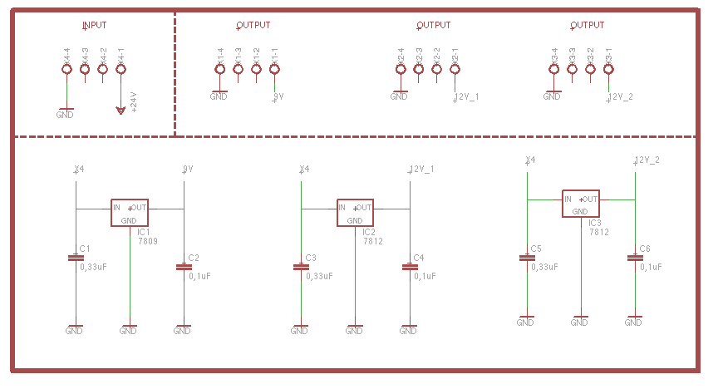

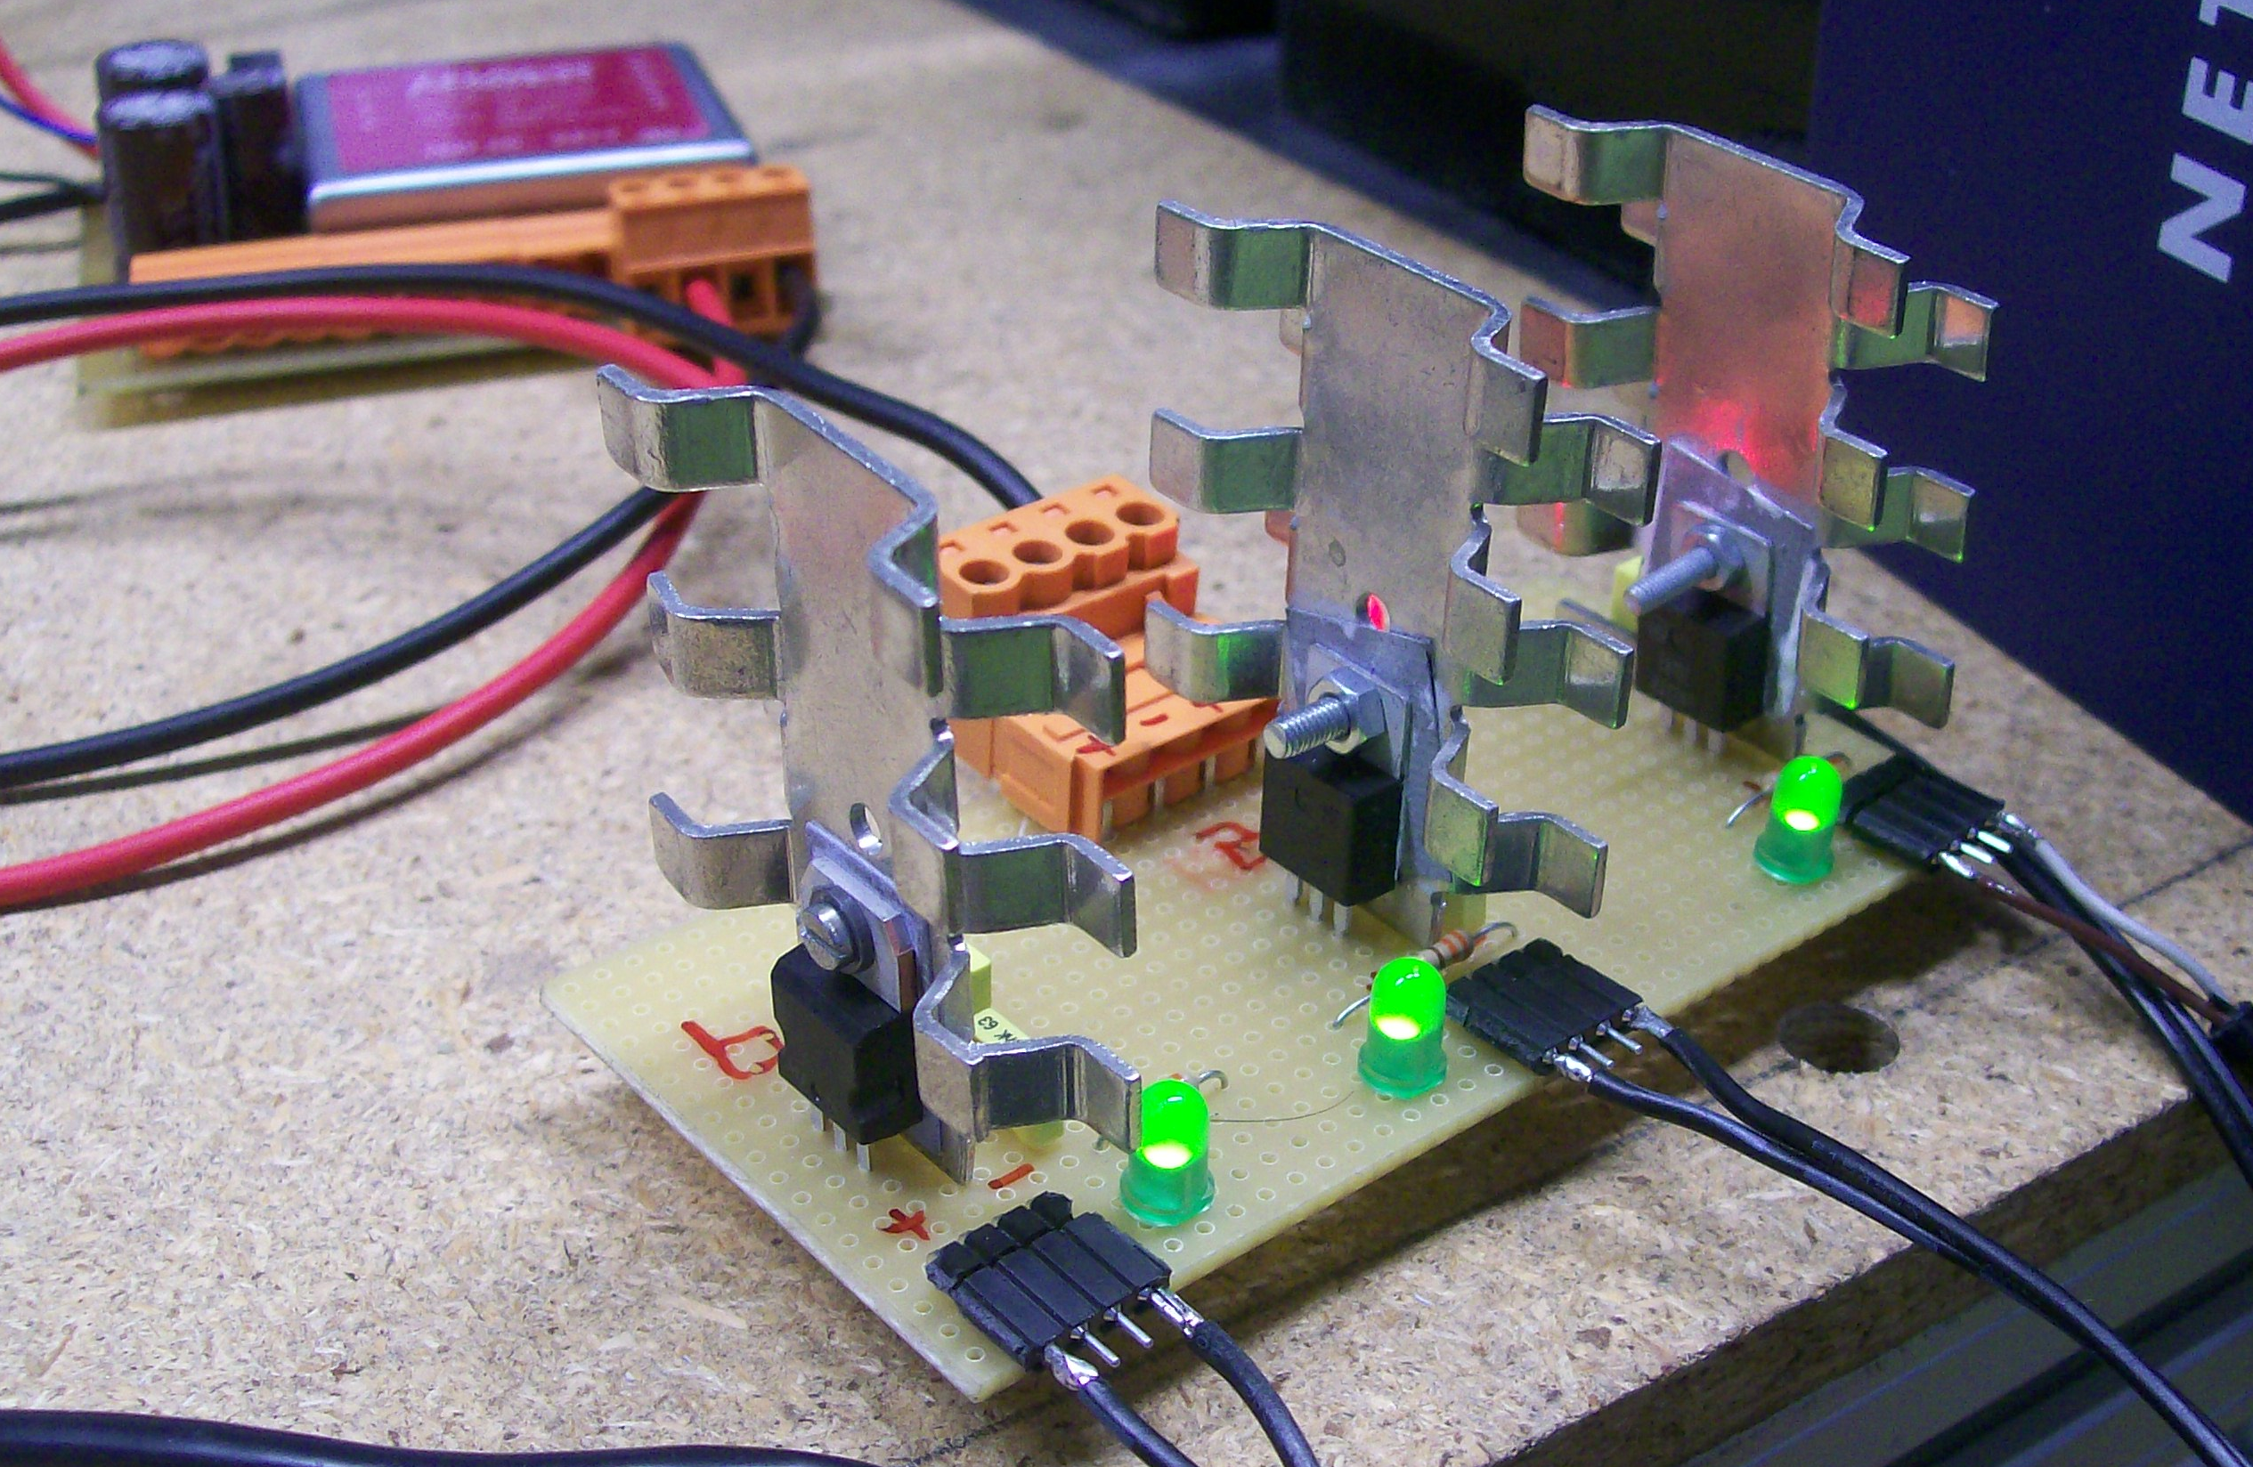

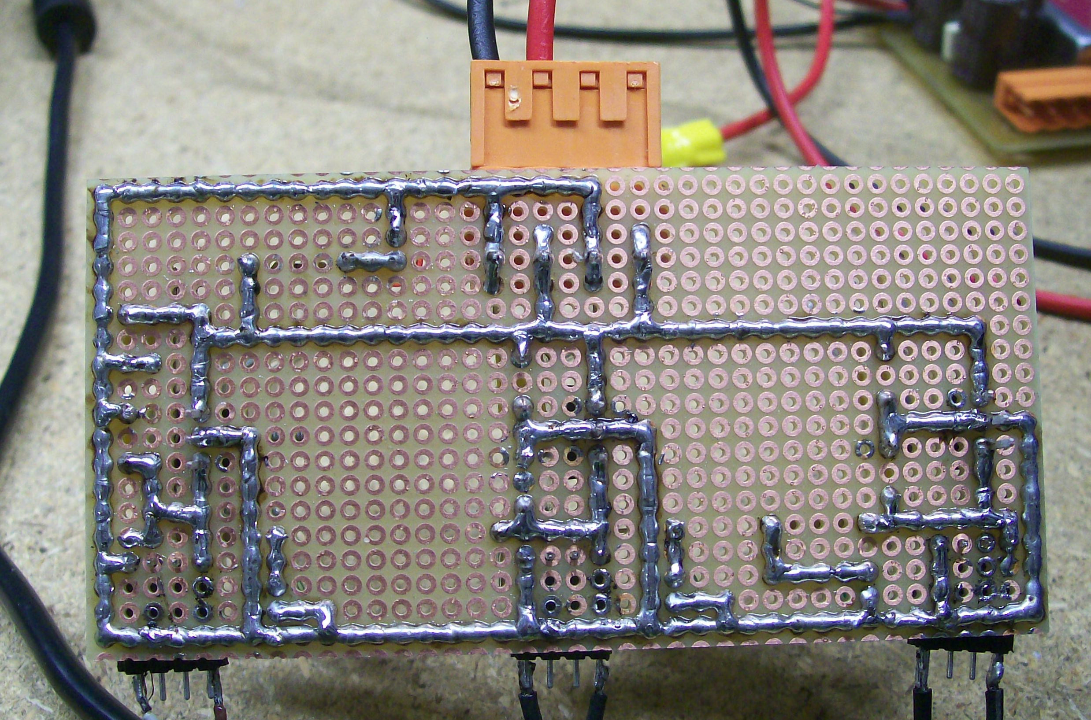

# Robot1

## Robot body:

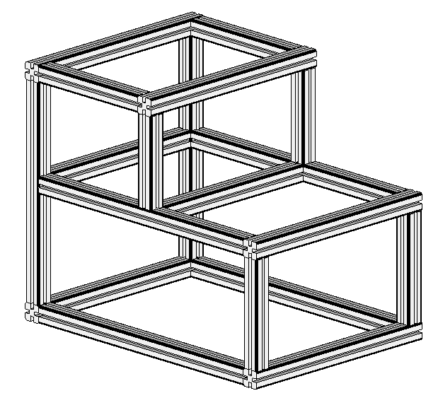

## Kinect_sensor

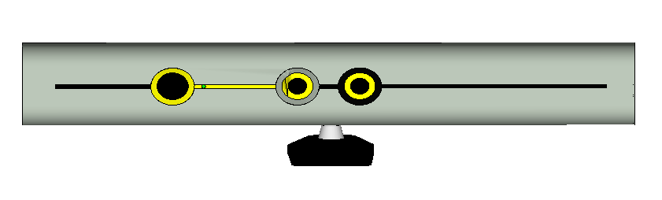

## Sick Laser PLS200

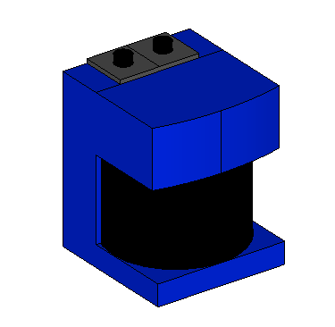

## Wheels 2 degree of freedom

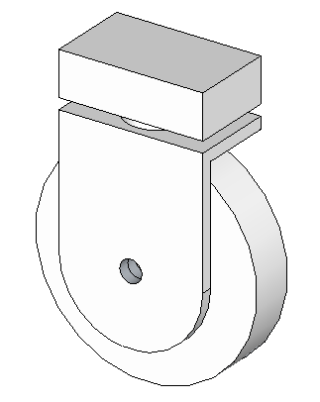

## Final model

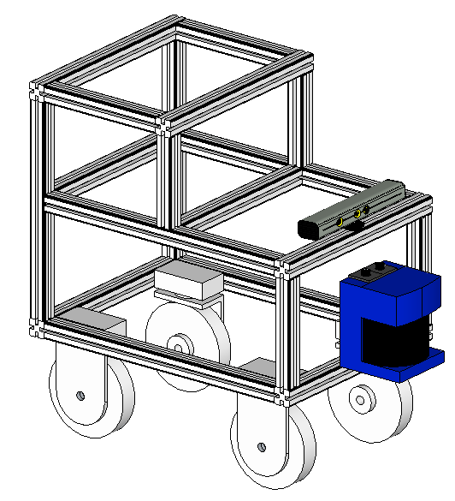

# Install Diamondback in Ubuntu

We are building Debian packages for several Ubuntu platforms, listed below. These packages are more efficient than source-based builds and are our preferred installation method for Ubuntu.

If you need to install from source, please see source (download-and-compile) installation instructions.

## Installation

### Configure your Ubuntu repositories

Configure your Ubuntu repositories to allow "restricted," "universe," and "multiverse." You can follow the Ubuntu guide for instructions on doing this.

### Setup your sources.list

Setup your computer to accept software from ROS.org.

Ubuntu 10.04 (Lucid)

sudo sh -c 'echo "deb http://packages.ros.org/ros/ubuntu lucid main" > /etc/apt/sources.list.d/ros-latest.list'

Ubuntu 10.10 (Maverick)

sudo sh -c 'echo "deb http://packages.ros.org/ros/ubuntu maverick main" > /etc/apt/sources.list.d/ros-latest.list'

Mirrors

### Set up your keys

wget http://packages.ros.org/ros.key -O - | sudo apt-key add -

### Installation

Make sure you have re-indexed the ROS.org server:

sudo apt-get update

There are many different libraries and tools in ROS. We provided four default configurations to get you started. You can also install ROS stacks individually.

Desktop-Full Install: (Recommended): ROS, rx, rviz, robot-generic libraries, 2D/3D simulators, navigation and 2D/3D perception

sudo apt-get install ros-diamondback-desktop-full

or click here

Desktop Install: ROS, rx, rviz, and robot-generic libraries

sudo apt-get install ros-diamondback-desktop

or click here

ROS-Base: (Bare Bones) ROS package, build, and communication libraries. No GUI tools.

sudo apt-get install ros-diamondback-ros-base

or click here

Individual Stack: You can also install a specific ROS stack (replace underscores with dashes of the stack name):

sudo apt-get install ros-diamondback-STACK

e.g.

sudo apt-get install ros-diamondback-slam-gmapping

### Environment setup

It's convenient if the ROS environment variables are automatically added to your bash session every time a new shell is launched:

echo "source /opt/ros/diamondback/setup.bash" >> ~/.bashrc

. ~/.bashrc

If you have more than one ROS distribution installed, ~/.bashrc must only source the setup.bash for the version you are currently using.

If you just want to change the environment of your current shell, you can type:

source /opt/ros/diamondback/setup.bash

# Download and compile the stack

In this project we are created a Stack to ROS (Robot Operating System). This stack contain all the code, drivers and nodes developed in the peoject.

The code is hosted in github (http://www.github.com) in the next url:

https://github.com/AaronMR/JKU_Robotic_Stack

To download all the code from the repositories, we can do it with the next lines:

cd

cd dev

git clone git://github.com/AaronMR/JKU_Robotic_Stack.git

now is necessary update your ROS_PACKAGE_PATH environment variable

export ROS_PACKAGE_PATH=~/dev/JKU_Robotic_Stack:$ROS_PACKAGE_PATH

Now we need compile all the nodes

rosmake R1_Odom

rosmake R1_teleop_joy

rosmake R1_teleop_key

rosmake Laser_PLS200

# Install Development Tools

In the project we are using:

Code::Blocks

Kile

## Script to install from Code::Blocks from SVN

#! /bin/bash

cd

mkdir dev # creamos una carpeta para descargar todo y compilar todo

cd dev

mkdir codeblocks

cd codeblocks

sudo apt-get install build-essential libgtk2.0-dev libwxgtk2.8-0 libwxgtk2.8-dev wx-common subversion autoconf automake libtool gobjc++ cmake-curses-gui

svn checkout svn://svn.berlios.de/codeblocks/trunk

cd trunk

export ACLOCAL_FLAGS="-I ‘wx-config --prefix‘/share/aclocal"

./bootstrap

./configure --with-contrib-plugins=all

make

sudo make install

echo /usr/local/lib | sudo tee -a /etc/ld.so.conf

sudo ldconfig

## Install Kile from the repositories

Only we need execute the next comand:

sudo apt-get install kile

# Setup and Configuration of the Navigation Stack on a Robot

This tutorial provides step-by-step instructions for how to get the navigation stack running on a robot. Topics covered include: sending transforms using tf, publishing odometry information, publishing sensor data from a laser over ROS, and basic navigation stack configuration.

## Robot Setup

The navigation stack assumes that the robot is configured in a particular manner in order to run. The diagram above shows an overview of this configuration. The white components are required components that are already implemented, the gray components are optional components that are already implemented, and the blue components must be created for each robot platform. The pre-requisites of the navigation stack, along with instructions on how to fulfil each requirement, are provided in the sections below.

### ROS

The navigation stack assumes that the robot is using ROS. Please consult the ROS documentation for instructions on how to install ROS on your robot.

### Transform Configuration (other transforms)

The navigation stack requires that the robot be publishing information about the relationships between coordinate frames using tf. A detailed tutorial on setting up this configuration can be found here: Transform Configuration.

### Sensor Information (sensor sources)

The navigation stack uses information from sensors to avoid obstacles in the world, it assumes that these sensors are publishing either sensor_msgs/LaserScan or sensor_msgs/PointCloud messages ove ROS. For information on publishing these messages over ROS, please see the Publishing Sensor Streams Over ROS tutorial. Also, there are a number of sensors that have ROS drivers that already take care of this step. Supported sensors and links to their appropriate drivers are listed below:

SCIP2.0-compliant Hokuyo Laser Devices as well as the Hokuyo Model 04LX - hokuyo_node

SICK LMS2xx Lasers - sicktoolbox_wrapper

### Odometry Information (odometry source)

The navigation stack requires that odometry information be published using tf and the nav_msgs/Odometry message. A tutorial on publishing odometry information can be found here: Publishing Odometry Information Over ROS. Supported platforms for odometry and links to their appropriate drivers are listed below:

Videre Erratic: erratic_player

PR2: pr2_mechanism_controllers

### Base Controller (base controller)

The navigation stack assumes that it can send velocity commands using a geometry_msgs/Twist message assumed to be in the base coordinate frame of the robot on the "cmd_vel" topic. This means there must be a node subscribing to the "cmd_vel" topic that is capable of taking (vx, vy, vtheta) <==> (cmd_vel.linear.x, cmd_vel.linear.y, cmd_vel.angular.z) velocities and converting them into motor commands to send to a mobile base. Supported platforms for base control and links to their appropriate drivers are listed below:

Videre Erratic: erratic_player

PR2: pr2_mechanism_controllers

### Mapping (map_server)

The navigation stack does not require a map to operate, but for the purposes of this tutorial, we'll assume you have one. Please see the building a map tutorial for details on creating a map of your environment.

## Navigation Stack Setup

This section describes how to setup and configure the navigation stack on a robot. It assumes that all the requirements above for robot setup have been satisfied. Specifically, this means that the robot must be publishing coordinate frame information using tf, receiving sensor_msgs/LaserScan or sensor_msgs/PointCloud messages from all sensors that are to be used with the navigation stack, and publishing odometry information using both tf and the nav_msgs/Odometry message while also taking in velocity commands to send to the base. If any of these requirements are not met on your robot, please see the Robot Setup section above for instructions on completing them.

### Creating a Package

This first step for this tutorial is to create a package where we'll store all the configuration and launch files for the navigation stack. This package will have dependencies on any packages used to fulfill the requirements in the Robot Setup section above as well as on the move_base package which contains the high-level interface to the navigation stack. So, pick a location for your package and run the following command:

roscreate-pkg my_robot_name_2dnav move_base my_tf_configuration_dep my_odom_configuration_dep my_sensor_configuration_dep

This command will create a package with the necessary dependencies to run the navigation stack on your robot.

### Creating a Robot Configuration Launch File

Now that we have a workspace for all of our configuration and launch files, we'll create a roslaunch file that brings up all the hardware and transform publishes that the robot needs. Fire up your favorite editor, and paste the following snippet into a file called my_robot_configuration.launch. You should, of course, feel free to replace the text "my_robot" with the name of your actual robot. We'll also have to make similar changes to the launch file as discussed below, so make sure that you read the rest of this section.

<launch>

<node pkg="sensor_node_pkg" type="sensor_node_type" name="sensor_node_name" output="screen">

<param name="sensor_param" value="param_value" />

</node>

<node pkg="odom_node_pkg" type="odom_node_type" name="odom_node" output="screen">

<param name="odom_param" value="param_value" />

</node>

<node pkg="transform_configuration_pkg" type="transform_configuration_type" name="transform_configuration_name" output="screen">

<param name="transform_configuration_param" value="param_value" />

</node>

</launch>

Ok.. so now we have a template for a launch file, but we need to fill it in for our specific robot. We'll walk through the changes that need to be made in each section below.

<launch>

<node pkg="sensor_node_pkg" type="sensor_node_type" name="sensor_node_name" output="screen">

<param name="sensor_param" value="param_value" />

In this section, we'll bring up any sensors that the robot will use for navigation. Replace "sensor_node_pkg" with the name of the package for the ROS driver for your sensor, "sensor_node_type" with the type of the driver for your sensor, "sensor_node_name" with the desired name for your sensor node, and "sensor_param" with any parameters that your node might take. Note that if you have multiple sensors that you intend to use to send information to the navigation stack, you should launch all of them here.

<node pkg="odom_node_pkg" type="odom_node_type" name="odom_node" output="screen">

<param name="odom_param" value="param_value" />

</node>

In this section, we'll launch the odometry for the base. Once again, you'll need to replace the pkg, type, name, and param specifications with those relevant to the node that you're actually launching.

<node pkg="transform_configuration_pkg" type="transform_configuration_type" name="transform_configuration_name" output="screen">

<param name="transform_configuration_param" value="param_value" />

</node>

In this section, we'll launch the transform configuration for the robot. Once again, you'll need to replace the pkg, type, name, and param specifications with those relevant to the node that you're actually launching.

### Costmap Configuration (local_costmap) & (global_costmap)

The navigation stack uses two costmaps to store information about obstacles in the world. One costmap is used for global planning, meaning creating long-term plans over the entire environment, and the other is used for local planning and obstacle avoidance. There are some configuration options that we'd like both costmaps to follow, and some that we'd like to set on each map individually. Therefore, there are three sections below for costmap configuration: common configuration options, global configuration options, and local configuration options.

Note: The following sections cover only basic configuration options for the costmap. For documentation on the full range of opitons, please see the costmap_2d documentation.

Common Configuration (local_costmap) & (global_costmap)

The navigation stack uses costmaps to store information about obstacles in the world. In order to do this properly, we'll need to point the costmaps at the sensor topics they should listen to for updates. Let's create a file called costmap_common_params.yaml as shown below and fill it in:

obstacle_range: 2.5

raytrace_range: 3.0

footprint: [[x0, y0], [x1, y1], ... [xn, yn]]

#robot_radius: ir_of_robot

inflation_radius: 0.55

observation_sources: laser_scan_sensor point_cloud_sensor

laser_scan_sensor: {sensor_frame: frame_name, data_type: LaserScan, topic: topic_name, marking: true, clearing: true}

point_cloud_sensor: {sensor_frame: frame_name, data_type: PointCloud, topic: topic_name, marking: true, clearing: true}

Ok, let's break down the file above into manageable parts.

obstacle_range: 2.5

raytrace_range: 3.0

These parameters set thresholds on obstacle information put into the costmap. The "obstacle_range" parameter determines the maximum range sensor reading that will result in an obstacle being put into the costmap. Here, we have it set at 2.5 meters, which means that the robot will only update its map with information about obstacles that are within 2.5 meters of the base. The "raytrace_range" parameter determines the range to which we will raytrace freespace given a sensor reading. Setting it to 3.0 meters as we have above means that the robot will attempt to clear out space in front of it up to 3.0 meters away given a sensor reading.

footprint: [[x0, y0], [x1, y1], ... [xn, yn]]

#robot_radius: ir_of_robot

inflation_radius: 0.55

Here we set either the footprint of the robot or the radius of the robot if it is circular. In the case of specifying the footprint, the center of the robot is assumed to be at (0.0, 0.0) and both clockwise and counterclockwise specifications are supported. We'll also set the inflation radius for the costmap. The inflation radius should be set to the maximum distance from obstacles at which a cost should be incurred. For example, setting the inflation radius at 0.55 meters means that the robot will treat all paths that stay 0.55 meters or more away from obstacles as having equal obstacle cost.

observation_sources: laser_scan_sensor point_cloud_sensor

The "observation_sources" parameter defines a list of sensors that are going to be passing information to the costmap separated by spaces.

laser_scan_sensor: {sensor_frame: frame_name, data_type: LaserScan, topic: topic_name, marking: true, clearing: true}

This line sets parameters on a laser_scan_sensor. The "frame_name" parameter should be set to the name of the coordinate frame of the sensor, the "data_type" parameter should be set to LaserScan or PointCloud depending on which message the topic uses, and the "topic_name" should be set to the name of the topic that the sensor publishes data on. The "marking" and "clearing" parameters determine whether the sensor will be used to add obstacle information to the costmap, clear obstacle information from the costmap, or do both.

### Global Configuration (global_costmap)

We'll create a file below that will store configuration options specific to the global costmap. Open up an editor with the file global_costmap_params.yaml and paste in the following text:

global_costmap:

global_frame: /map

robot_base_frame: base_link

update_frequency: 5.0

static_map: true

The "global_frame" parameter defines what coordinate frame the costmap should run in, in this case, we'll choose the /map frame. The "robot_base_link" parameter defines the coordinate frame the costmap should reference for the base of the robot. The "update_frequency" parameter determines the frequency, in Hz, at which the costmap will run its update loop. The "static_map" parameter determines whether or not the costmap should initialize itself based on a map served by the map_server. If you aren't using an existing map or map server, set the static_map parameter to false.

### Local Configuration (local_costmap)

We'll create a file below that will store configuration options specific to the local costmap. Open up an editor with the file local_costmap_params.yaml and paste in the following text:

local_costmap:

global_frame: odom

robot_base_frame: base_link

update_frequency: 5.0

publish_frequency: 2.0

static_map: false

rolling_window: true

width: 6.0

height: 6.0

resolution: 0.05

The "global_frame", "robot_base_frame", "update_frequency", and "static_map" parameters are the same as described in the Global Configuration section above. The "publish_frequency" parameter determines the rate, in Hz, at which the costmap will publish visualization information. Setting the "rolling_window" parameter to true means that the costmap will remain centered around the robot as the robot moves through the world. The "width," "height," and "resolution" parameters set the width (meters), height (meters), and resoltion (meters/cell) of the costmap. Note that its fine for the resolution of this grid to be different than the resolution of your static map, but most of the time we tend to set them equally.

### Full Configuration Options

This minimum configuration should get things up and running, but for more details on the configuration options available for the costmap please see the costmap_2d documentation.

## Base Local Planner Configuration

The base_local_planner is responsible for computing velocity commands to send to the mobile base of the robot given a high-level plan. We'll need to set some configuration options based on the specs of our robot to get things up and running. Open up a file called base_local_planner_params.yaml and paste the following text into it:

Note: This section covers only basic configuration options for the TrajectoryPlanner. For documentation on the full range of opitons, please see the base_local_planner documentation.

TrajectoryPlannerROS:

max_vel_x: 0.45

min_vel_x: 0.1

max_rotational_vel: 1.0

min_in_place_rotational_vel: 0.4

acc_lim_th: 3.2

acc_lim_x: 2.5

acc_lim_y: 2.5

holonomic_robot: true

The first section of parameters above define the velocity limits of the robot. The second section defines the acceleration limits of the robot.

## Creating a Launch File for the Navigation Stack

Now that we've got all of our configuration files in place, we'll need to bring everything together into a launch file for the navigation stack. Open up an editor with the file move_base.launch and paste the following text into it:

<launch>

<master auto="start"/>

<!-- Run the map server -->

<node name="map_server" pkg="map_server" type="map_server" args="$(find my_map_package)/my_map.pgm my_map_resolution"/>

<!--- Run AMCL -->

<include file="$(find amcl)/examples/amcl_omni.launch" />

<node pkg="move_base" type="move_base" respawn="false" name="move_base" output="screen">

<rosparam file="$(find my_robot_name_2dnav)/costmap_common_params.yaml" command="load" ns="global_costmap" />

<rosparam file="$(find my_robot_name_2dnav)/costmap_common_params.yaml" command="load" ns="local_costmap" />

<rosparam file="$(find my_robot_name_2dnav)/local_costmap_params.yaml" command="load" />

<rosparam file="$(find my_robot_name_2dnav)/global_costmap_params.yaml" command="load" />

<rosparam file="$(find my_robot_name_2dnav)/base_local_planner_params.yaml" command="load" />

</node>

</launch>

The only changes that you should need to make to this file are to change the map server to point to a map you've created and to change "amcl_omni.launch" to "amcl_diff.launch" if you have a differential drive robot. For a tutorial on creating a map, please see the building a map.

## AMCL Configuration (amcl)

AMCL has many configuration options that will affect the performance of localization. For more information on AMCL please see amcl documentation.

Running the Navigation Stack

Now that we've got everything set up, we can run the navigation stack. To do this we'll need two terminals on the robot. In one terminal, we'll launch the my_robot_configuration.launch file and in the other we'll launch the move_base.launch file that we just created.

Terminal 1:

roslaunch my_robot_configuration.launch

Terminal 2:

roslaunch move_base.launch

Congratulations, the navigation stack should now be running. For a information on sending goals to the navigation stack through a graphical interface, please see the rviz and navigation tutorial. If you want to send goals to the navigation stack using code instead, please see the Sending Simple Navigation Goals tutorial.

# Create your own urdf file

In this tutorial you start creating your own urdf robot description file.

Create the tree structure

In this tutorial we'll create the URDF description of the Robot1 shown in the image below.



The robot in the image a 3d model of the Robot1. In the next image we can see the the same model but like a tree structure.

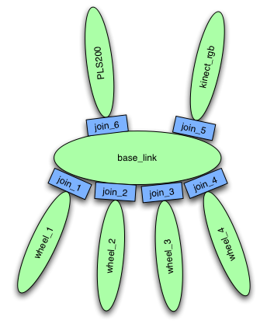

Fire up your favorite text editor, and create a file called my_urdf.xml:

<?xml version="1.0"?>

<robot name="flexible">

<link name="base_link">

<visual>

<geometry>

<mesh scale="0.025 0.025 0.025" filename="package://R1_urdf/bot_body.dae"/>

</geometry>

<origin xyz="0 0 0.226"/>

</visual>

</link>

<link name="kinect_rgb">

<visual>

<origin rpy="0 0 0" xyz="0 0 0"/>

<geometry>

<mesh scale="0.025 0.025 0.025" filename="package://R1_urdf/bot_kinect.dae"/>

</geometry>

<origin rpy="0 0 0" xyz="0 0 0"/>

</visual>

</link>

<joint name="tobox2" type="continuous">

<parent link="base_link"/>

<child link="kinect_rgb"/>

<origin rpy="-1.57 0 -1.570" xyz="0.320 0 0.555"/>

</joint>

<link name="wheel_1">

<visual>

<origin rpy="0 0 0" xyz="0 0 0"/>

<geometry>

<mesh scale="0.025 0.025 0.025" filename="package://R1_urdf/bot_wheel.dae"/>

</geometry>

</visual>

</link>

<joint name="tobox5" type="continuous">

<parent link="base_link"/>

<child link="wheel_1"/>

<axis xyz="0 0 1"/>

<origin rpy="0 0 0" xyz="0.235 -0.17 0"/>

</joint>

<link name="wheel_2">

<visual>

<origin rpy="0 0 0" xyz="0 0 0"/>

<geometry>

<mesh scale="0.025 0.025 0.025" filename="package://R1_urdf/bot_wheel.dae"/>

</geometry>

</visual>

</link>

<joint name="tobox6" type="continuous">

<parent link="base_link"/>

<child link="wheel_2"/>

<axis xyz="0 0 1"/>

<origin rpy="0 0 3.14" xyz="0.235 0.17 0"/>

</joint>

<link name="wheel_3">

<visual>

<origin rpy="0 0 0" xyz="0 0 0"/>

<geometry>

<mesh scale="0.025 0.025 0.025" filename="package://R1_urdf/bot_wheel.dae"/>

</geometry>

</visual>

</link>

<joint name="tobox7" type="continuous">

<parent link="base_link"/>

<child link="wheel_3"/>

<axis xyz="0 0 1"/>

<origin rpy="0 0 0 " xyz="-0.235 -0.17 0"/>

</joint>

<link name="wheel_4">

<visual>

<origin rpy="0 0 0" xyz="0 0 0"/>

<geometry>

<mesh scale="0.025 0.025 0.025" filename="package://R1_urdf/bot_wheel.dae"/>

</geometry>

</visual>

</link>

<joint name="tobox8" type="continuous">

<parent link="base_link"/>

<child link="wheel_4"/>

<axis xyz="0 0 1"/>

<origin rpy="0 0 3.14" xyz="-0.235 0.17 0"/>

</joint>

<link name="PLS200">

<visual>

<origin rpy="0 0 0" xyz="0 0 0"/>

<geometry>

<mesh scale="0.025 0.025 0.025" filename="package://R1_urdf/bot_PLS200.dae"/>

</geometry>

</visual>

</link>

<joint name="tobox9" type="continuous">

<parent link="base_link"/>

<child link="PLS200"/>

<origin rpy="0 0 0" xyz="0.420 0 0.26"/>

</joint>

</robot>

So, just creating the structure is very simple! Now let's see if we can get this urdf file parsed. There is a simple command line tool that will parse a urdf file for you, and tell you if the syntax is correct:

$ rosmake urdf

$ rosrun urdf check_urdf my_urdf.xml

If everything works correctly, the output should look like this:

robot name is: test_robot

---------- Successfully Parsed XML ---------------

root Link: link1 has 2 child(ren)

child(1): link2

child(2): link3

child(1): link4

Add the dimensions

So now that we have the basic tree structure, let's add the appropriate dimensions. As you notice in the robot image, the reference frame of each link (in green) is located at the bottom of the link, and is identical the the reference frame of the joint. So, to add dimensions to our tree, all we have to specify is the offset from a link, to the joint(s) of its children. To accomplish this, we will add the field <origin> to each of the joints.

Let's look at the second joint. Joint2 is offset in the Y-direction from link1, a little offset in the negative X-direction from link1, and it is rotated 90 degrees around the Z-axis. So, we need to add the following <origin> element:

[des]activar nros. de línea

1 <origin xyz="-2 5 0" rpy="0 0 1.57" />

If you repeat this for all the elements our URDF will look like this:

[des]activar nros. de línea

1 <robot name="test_robot">

2 <link name="link1" />

3 <link name="link2" />

4 <link name="link3" />

5 <link name="link4" />

6

7

8 <joint name="joint1" type="continuous">

9 <parent link="link1"/>

10 <child link="link2"/>

11 <origin xyz="5 3 0" rpy="0 0 0" />

12 </joint>

13

14 <joint name="joint2" type="continuous">

15 <parent link="link1"/>

16 <child link="link3"/>

17 <origin xyz="-2 5 0" rpy="0 0 1.57" />

18 </joint>

19

20 <joint name="joint3" type="continuous">

21 <parent link="link3"/>

22 <child link="link4"/>

23 <origin xyz="5 0 0" rpy="0 0 -1.57" />

24 </joint>

25 </robot>

Update your file my_urdf.xml and run it through the parser:

$ rosrun urdf check_urdf my_urdf.xml

If it all looks good, you can move to the next step.

Completing the Kinematics

What we didn't specify yet is around which axis the joints rotate. Once we add that, we actually have a full kinematic model of this robot! All we need to do is add the <axis> element to each joint. The axis specifies the rotational axis in the local frame.

So, if you look at joint2, you see it rotates around the positive Y-axis. So, simple add the following xml to the joint element:

[des]activar nros. de línea

1 <axis xyz="0 1 0" />

Similarly, joint1 is rotating around the following axis:

[des]activar nros. de línea

1 <axis xyz="-0.707 0.707 0" />

Note that it is a good idea to normalize the axis.

If we add this to all the joints of the robot, our URDF looks like this:

[des]activar nros. de línea

1 <robot name="test_robot">

2 <link name="link1" />

3 <link name="link2" />

4 <link name="link3" />

5 <link name="link4" />

6

7 <joint name="joint1" type="continuous">

8 <parent link="link1"/>

9 <child link="link2"/>

10 <origin xyz="5 3 0" rpy="0 0 0" />

11 <axis xyz="-0.9 0.15 0" />

12 </joint>

13

14 <joint name="joint2" type="continuous">

15 <parent link="link1"/>

16 <child link="link3"/>

17 <origin xyz="-2 5 0" rpy="0 0 1.57" />

18 <axis xyz="-0.707 0.707 0" />

19 </joint>

20

21 <joint name="joint3" type="continuous">

22 <parent link="link3"/>

23 <child link="link4"/>

24 <origin xyz="5 0 0" rpy="0 0 -1.57" />

25 <axis xyz="0.707 -0.707 0" />

26 </joint>

27 </robot>

Update your file my_urdf.xml and run it through the parser:

$ rosrun urdf check_urdf my_urdf.xml

That's it, you created your first URDF robot description! Now you can try to visualize the URDF using graphiz:

$ rosrun urdf urdf_to_graphiz my_urdf.xml

and open the generated file with your favorite pdf viewer:

$ evince test_robot.pdf